Stretch and Challenge
University courses: GCSE
Here are some free university courses which will help to extend your learning. They are linked to specific topics which you will study at GCSE.

Global hazards
Earthquakes | https://www.open.edu/openlearn/science-maths-technology/geology/earthquakes/content-section-0?active-tab=description-tab
Come Rain or Shine: Understanding the Weather | https://www.futurelearn.com/courses/come-rain-or-shine
Distinctive landscapes
Managing Coastal Environments | https://www.open.edu/openlearn/nature-environment/the-environment/environmental-science/managing-coastal-environments/content-section-0?active-tab=description-tab
Changing Climate
Climate Change: Solutions | https://www.futurelearn.com/courses/climate-change-the-solutions | 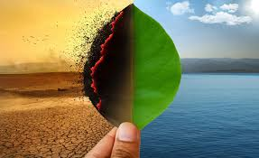
Sustainable Ecosystems
Valuing Nature: Should We Put a Price on Ecosystems? | https://www.futurelearn.com/courses/valuing-nature-should-we-put-a-price-on-ecosystems | 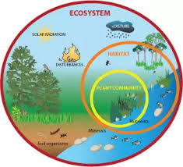
Dynamic Development
Introduction to Humanitarian Aid | https://www.futurelearn.com/courses/disaster-management
UK in the 21st Century
Cultural Heritage and the City | https://www.futurelearn.com/courses/cultural-heritage-cities | 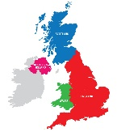
Urban futures
Changing Cities | https://www.open.edu/openlearn/society-politics-law/changing-cities/content-section-0
Migration and Cities | https://www.futurelearn.com/courses/migration-cities
Resource reliance
Global Water Resources | https://www.open.edu/openlearn/science-maths-technology/science/environmental-science/global-water-resources/content-section-0?active-tab=description-tab

If you have enjoyed these and want to do more, have a look at Future Learn, Open Yale courses, The Open University or UN CC: e-Learn.

