Stretch and Challenge
University courses: KS3
Here are some free Open University courses which will help to extend your learning. They are linked to specific topics which you will study at KS3.
Year 7: How do we use our planet?
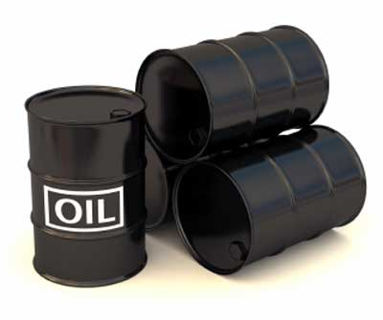
Living without oil | https://www.open.edu/openlearn/science-maths-technology/living-without-oil/content-section-0?active-tab=description-tab

Year 8: What happens when the land meets the sea?
Managing Coastal Environments | https://www.open.edu/openlearn/nature-environment/the-environment/environmental-science/managing-coastal-environments/content-section-0?active-tab=description-tab

Year 9: What is the future of our planet?
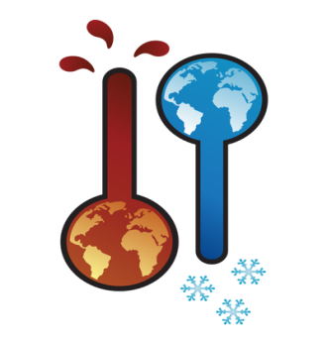
Climate Change | https://www.open.edu/openlearn/nature-environment/climate-change/content-section-0

