Digging Deeper into …
Urban Futures
The geography department would love for you to dig even deeper into your studies. Below are some suggestions for things you can do to stretch you in your learning. None of it is compulsory but for you to enjoy.
The distance between us by Reyna Grande

These foolish things by Deborah Moggach

The Wall by William Sutcliff

https://metro.co.uk/2016/02/02/13-reasons-leeds-is-the-best-place-to-live-in-the-uk-5645038/

https://www.lonelyplanet.com/india/bengaluru-bangalore
https://www.visitleeds.co.uk/

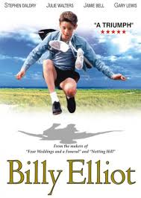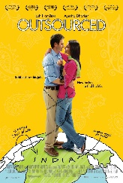

 | https://www.rgs.org/schools/teaching-resources/global-cities,-gentrification-and-creative-pra-(1)/  Global cities, gentrification and creative practices from the RGS | https://www.rgs.org/schools/teaching-resources/chinese-cities-and-urban-life/  Chinese cities and urban life from the RGS

https://www.youtube.com/watch?v=aa6DChXkeMQ&list=PLQygHVIU1mb3WD9rv-RMpq-AdoYstCUwx&index=10
Lecture from The University of Holloway about Changing Places

If you would like to share what you’ve learnt, we’d love for you to produce a piece that we could share with other students.

