Digging Deeper into …
What is the future of our planet?
The geography department would love for you to dig even deeper into your studies. Below are some suggestions for things you can do to stretch you in your learning. None of it is compulsory but for you to enjoy.

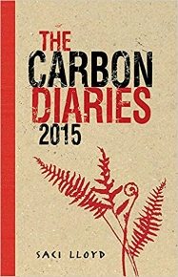 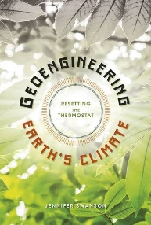 Books to read about climate change

https://www.theguardian.com/environment/climate-change

Link to newspaper articles about climate change from the Guardian.

Movies to watch about climate change

 | https://www.bbc.co.uk/sounds/play/b06qhyv8  BBC 4 radio programme about the science politics and solutions to climate change. | https://www.bbc.co.uk/programmes/p0391hnl  Podcast exploring the dangerous of co2 emissions and climate change.  https://geographical.co.uk/podcasts/item/4178-the-geographical-podcast-save-forests-store-carbon podcasts about saving forests and storing carbon

https://www.youtube.com/watch?v=nod5UbK1OnE
An interview with Dr Madeleine Morris about local energy futures to watch

https://www.bbc.co.uk/iplayer/episode/m00049b1/climate-change-the-facts
David Attenborough on climate change

https://www.bbc.co.uk/iplayer/episode/m000bh4j/my-life-series-11-2-saving-our-beautiful-bali

If you would like to share what you’ve learnt, we’d love for you to produce a piece that we could share with other students.

